How to Update Processing Chamber SolidWorks Files

The processing chamber will need to be updated to reflect the dimensions of the hydrogel heart valve. The current model is for the mechanical heart valve that was being tested.

1. **Top of the Processing Chamber**
   1. The first important thing to note is that 10 different SolidWorks files were created for valves ranging from 10-30mm in increments of 2mm. The file name doesn’t necessarily correlate with the same size of the valve that is being created. For instance, the title “TopChamber_24mm” refers to the opening diameter of the aortic root. This diameter is actually the outer diameter of where the leaflets are inserted, highlighted in Figure 1 as “Outer Leaflet Diameter”. This will change depending on the dimensions of the heart valve.

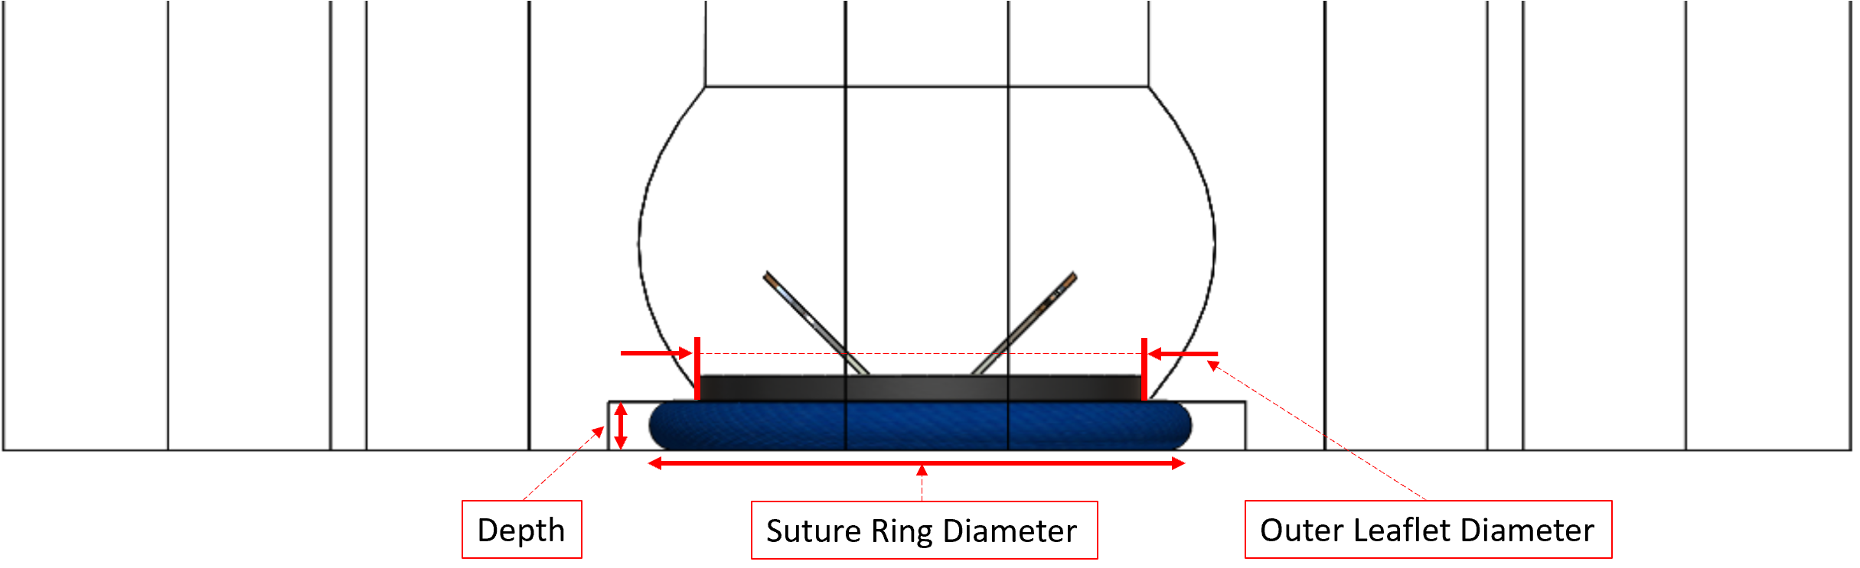

Figure 1

* 1. The mechanical valve that we were given was a size 22. It had an inner diameter of 20mm, an outer leaflet diameter of 24mm, an outer suture ring compression diameter of about 32mm and a suture ring depth of 3.15mm. The heart valve is clamped in place by the suture ring. The dimensions are shown below.

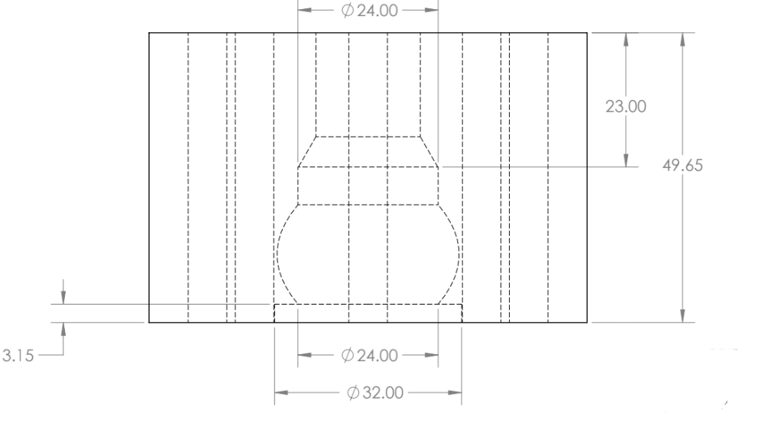

Figure 2

* 1. The dimensions will need to be edited in the SolidWorks tree.The SolidWorks tree is shown in Figure 3. The key dimensions are the “Outer Leaflet Diameter” and “Depth”. Most likely, the NPT Hole, Aortic Root, Ascending Aorta, and Bolts Holes will not need to be changed, as they do not specifically hold the heart valve in place.

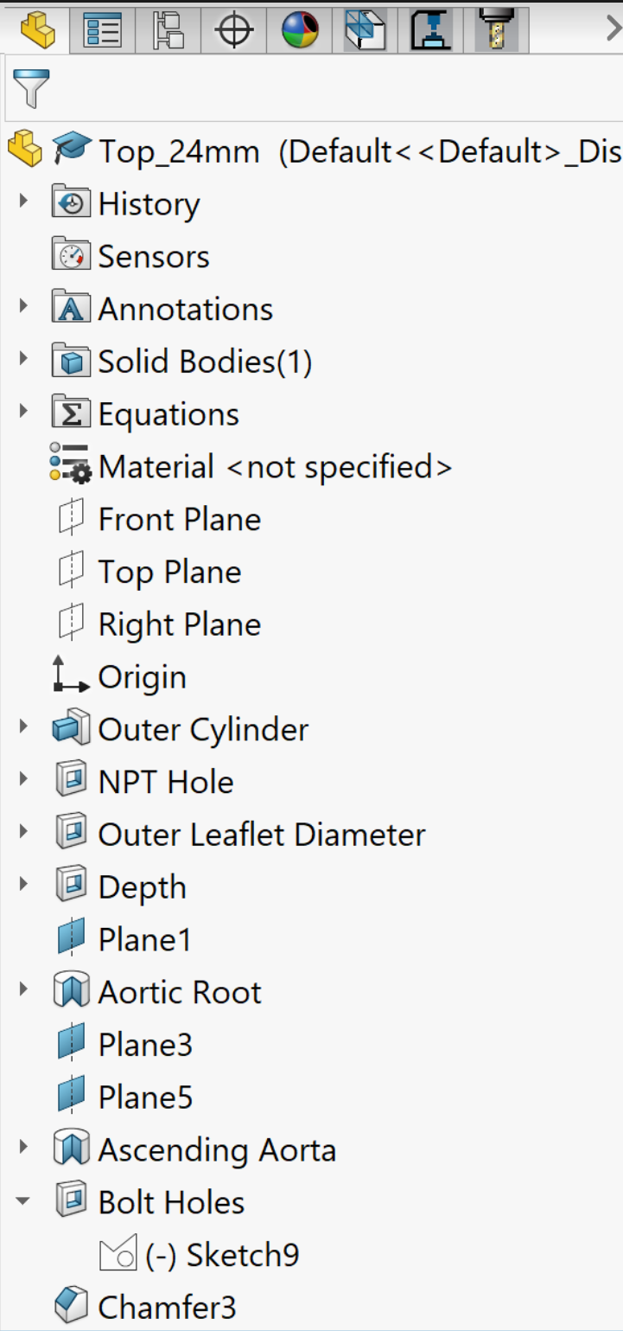

Figure 3

* 1. One of the dimensions that will most likely need to be changed is the diameter of the outer leaflet diameter. As mentioned earlier, the SolidWorks file is named in reference to this diameter. The Top_24mm means that the outer leaflet diameter is 24mm. All of the aortic root dimensions are tied to the outer leaflet diameter through equations, shown in Figure 4. The equations are shown in Figure 4. The aortic root opening is the same diameter as the outer leaflet diameter “A”; in the SolidWorks model this is shown as “D2@Sketch6” and the equation is A/2, because it is a cut revolve so only half of the outline was drawn and then revolved around the centerline.. The diameter where the aortic root opens into the ascending aorta is also the same diameter as “A”; in the SolidWorks model this is shown as “D3@Sketch” and the equation is A/2, because it is a cut revolve so only half of the outline was drawn and then revolved around the centerline. The height of the aortic root .71x the outer leaflet diameter size “A”, and is called “Aortic Root Height” in global variables. The maximum diameter of the aortic root occurs at half the aortic root height and is called “Max Diameter Height” in global variables. The maximum diameter of the aortic root is 1.3x larger than the outer leaflet diameter and is shown as “Max Diameter” in the global variables; to reiterate the aortic root was created using a revolve cut which is why the equation shows A*0.65 (half of 1.3). Every time the outer leaflet diameter is adjusted, these values automatically adjust with it.

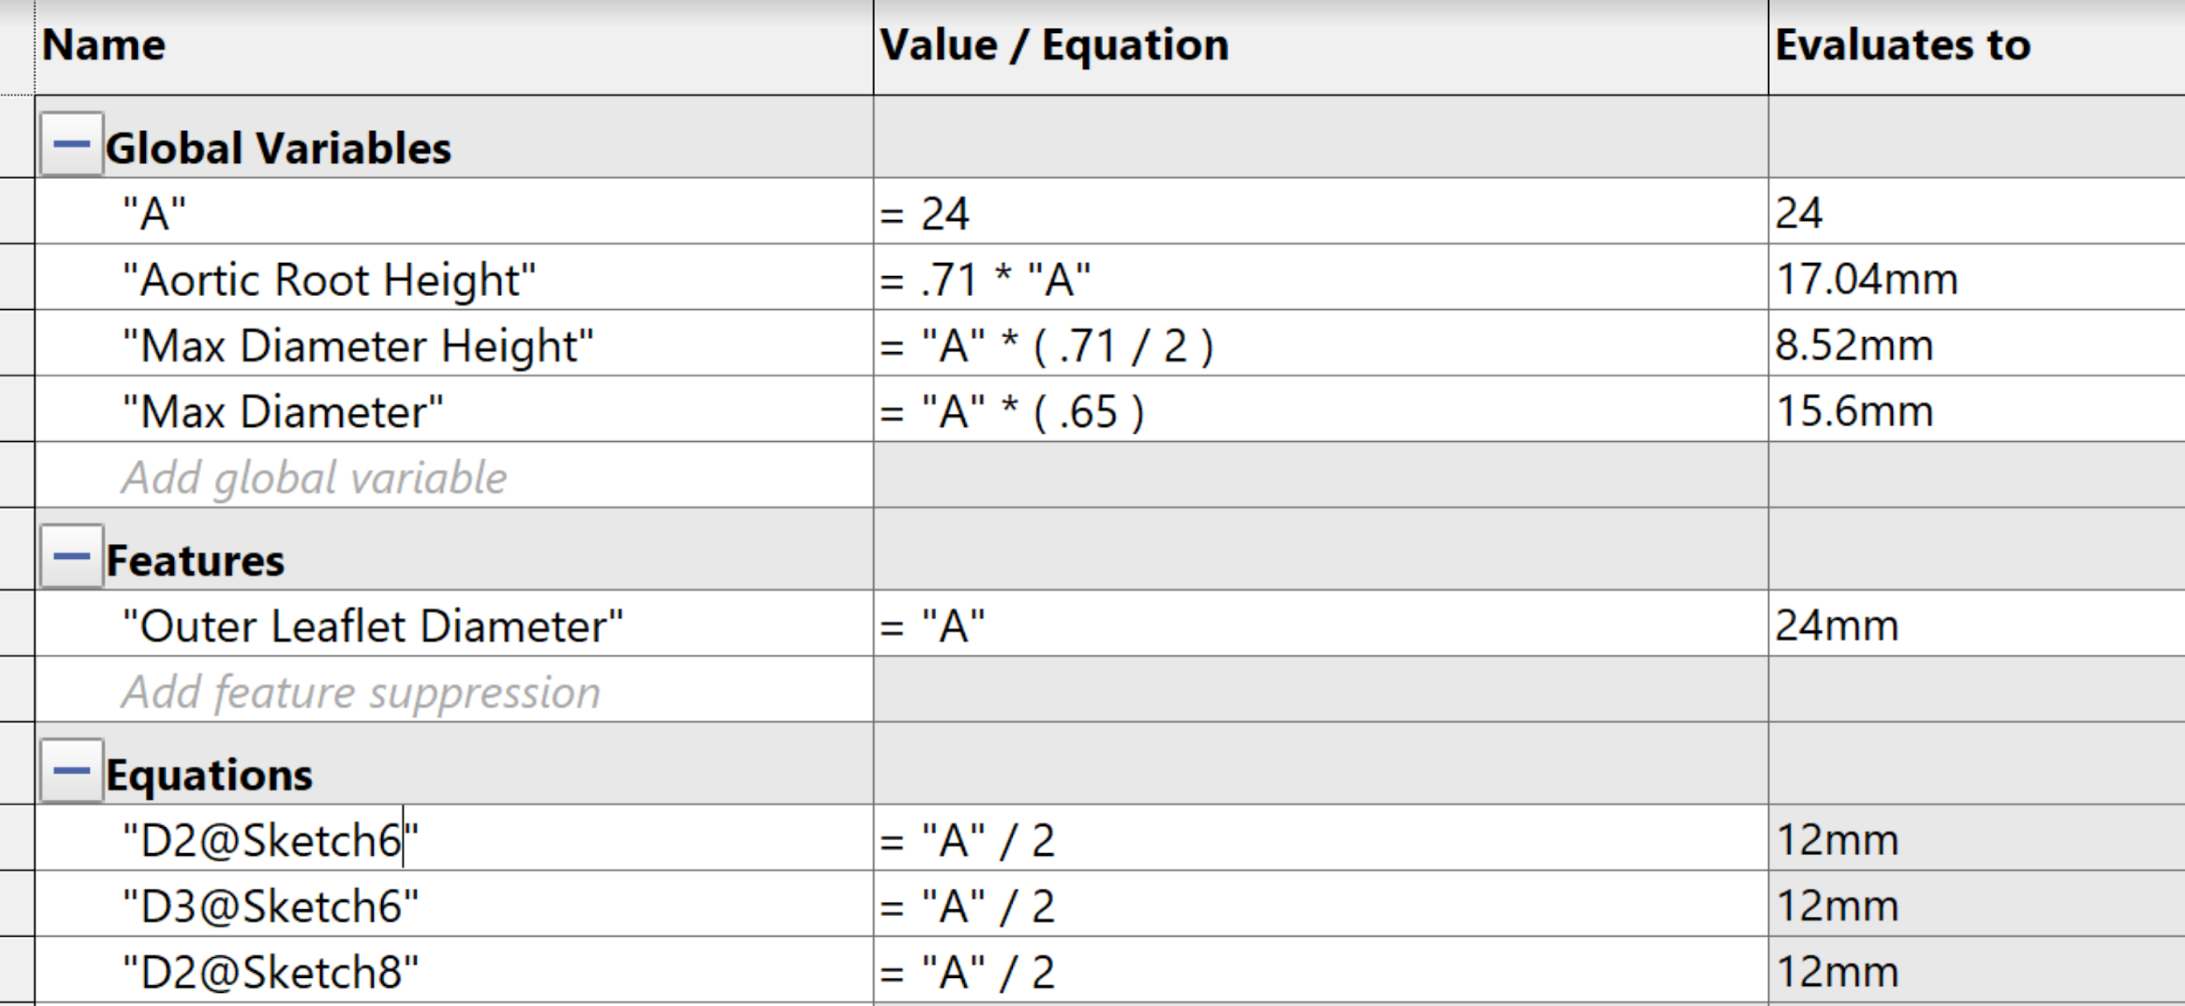

Figure 4: Aortic Root Equations

* 1. For the hydrogel heart valve, the dimensions for holding it in place will need to be changed. The rigid ring of the valve needs to be held firmly in place throughout testing. To ensure this happens the cut extrude of depth will need to be changed to match whatever the depth of the suture ring being used is. Also, the diameter of the depth will need to be changed to ensure it is wider than the width of the compressed suture ring. In our SolidWorks model an extra 2mm was added to this depth diameter, to ensure that the fabric on the ring will not be clamped outside of its designated cutout. Lastly, the outer leaflet diameter will have to be adjusted to whatever the diameter is of the portion of the valve extruding into the aortic root.

1. **Bottom of the Processing Chamber**
   1. The bottom of the processing chamber is a cylinder with a flat face that mates with the top of the processing chamber to hold the heart valve in place. The two key dimensions of the bottom of the processing chamber are the inlet flow diameter and o-ring groove (Figure 5).

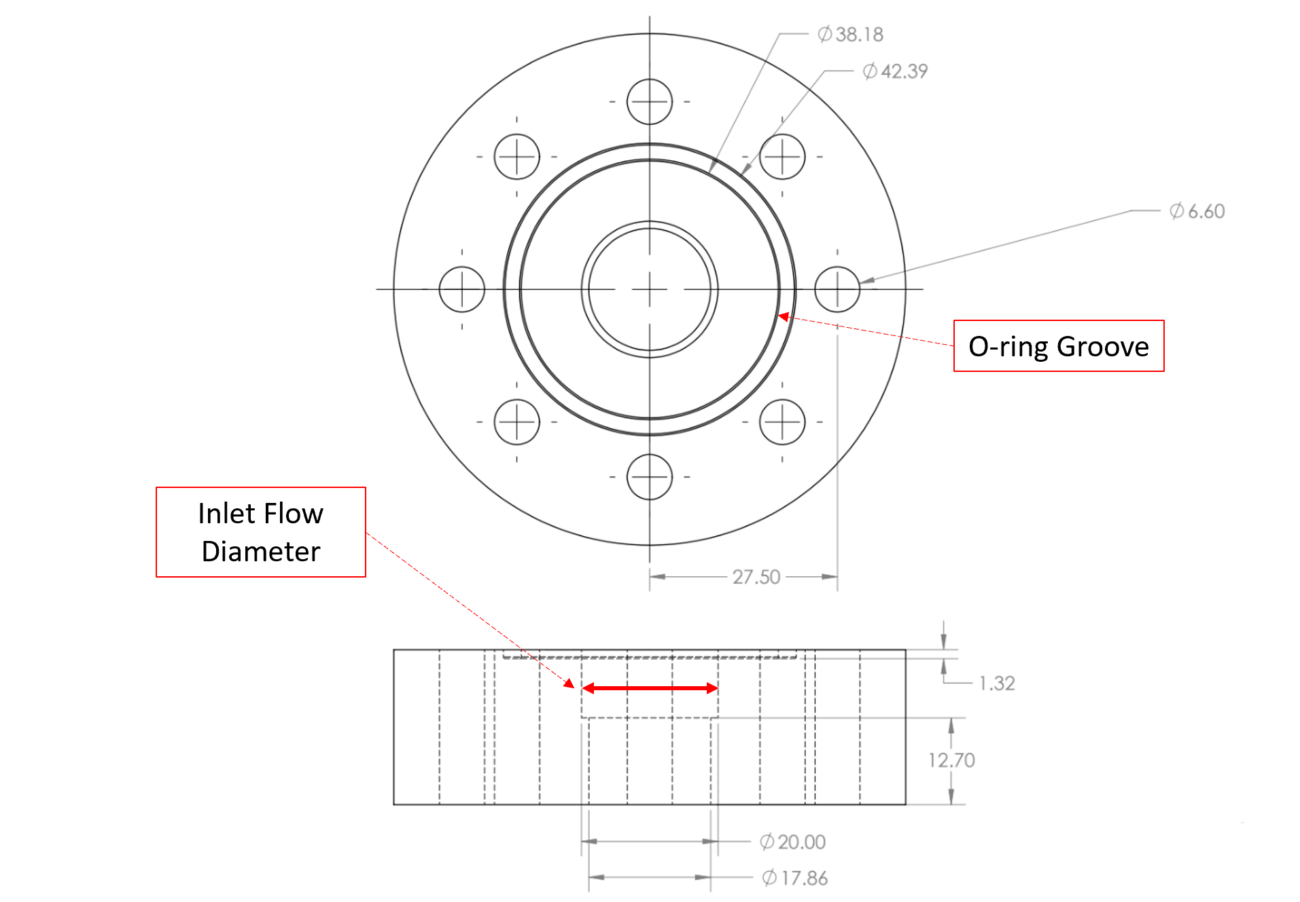

Figure 5: Bottom Chamber Diagram